ASCC PROPOSAL FOR A REVISED GENERAL EDUCATION PROGRAM
Rationale
In Spring 2018, OAA released a proposal to create a University-wide General Education Curriculum. The proposal responded to the charge from the University Level Advisory Committee on the General Education (ULAC) through a multi-semester process of discussion, study, and development involving faculty, students, and staff. That proposal and a discussion of the process that led to its development is available here https://oaa.osu.edu/general-education-review.
The OAA proposal has been the focus of intense discussion within the Colleges of the University. Within the College of Arts and Sciences, this proposal stimulated discussion and debate in the Arts and Sciences Curriculum Committee (ASCC) and in the Arts and Sciences Faculty Senate. As a result of these discussions, the Arts and Sciences Curriculum Committee has developed a revised proposal, detailed below.
Our proposed revisions are intended to create a bolder, more distinctive identity for the General Education curriculum at OSU within a smaller credit footprint. The total credits in our revised proposal are fewer than those in the present Arts and Sciences GE and in the proposal produced by the OAA General Education Review Committee.
The reduction in credits is intended to relieve pressure on STEM-based programs that lack flexibility in credits due to labs and a high number of foundational courses. Under the OAA model, virtually all the STEM-based programs say they can accommodate the GE requirements only if allowed a great deal of overlap with the major (or major prerequisites) for the Themes courses, and/or allowed substitutions in the Foundations courses (e.g., changing the Arts foundation course to “Arts or any other foundation course”—i.e., another science/math course). We think that these accommodations will effectively erase the GE’s distinctive programmatic identity, and fear that students will end up meeting the letter, but not the spirit, of the GE curriculum.
A primary rationale for the General Education revision is that it provides a strong introduction to the breadth of disciplines and modes of inquiry and then allows students the space within their total academic program to explore those disciplines through secondary programs (minors, double majors, certificates) and through electives. Thus, we consider it essential that units not expand the credit requirements of their majors or specializations in response to this reduction in GE hours. We strongly encourage programs to reduce barriers that restrict enrollment across colleges and eliminate prescribed and highly specific pathways through the GE as a means of meeting time-to-degree for majors.
Details of implementation remain to be discussed for many aspects of this proposal. These include, but are not limited to, specific learning outcomes for each category and element, the approval process for courses within the GE, the identity of the choice Themes, and credit-sharing for team-taught courses. We consider these important, but also recognize that the resolution of these details may need to be dynamic over time and may require negotiation among college leaders and between college leaders and OAA. Thus, approval of this proposal by the faculty is approval of the structure, distribution of credits, and general framework specified here, rather than of all specific (and as-yet unspecified) implementation details.

ASCC modifications to the OAA Proposal
Our revised proposal modifies the form and structure proposed by the OAA GE Review Committee. The text below refers to that proposal and is supported by a schematic diagram (Appendix).

- Bookends
In the OAA model, the General Education Seminar (the first “bookend” course) is a 3-credit, seminar-sized, faculty-taught course in which “students explore a contemporary topic, issue, idea, or problem from a multidisciplinary perspective. . . Students understand the structure and value of the general education program and recognize the attributes of an educated global citizen.”
Implementing this element of the GE as envisioned on the OAA proposal will be very challenging, in terms of staffing and costs (across campus, but even more so on the regional campuses). It will also be challenging to assure that these seminars do not devolve into conventional introductory courses in their disciplines, as opposed to being genuinely interdisciplinary courses that also introduce students to the philosophy and structure of the GE. Moreover, the rationale for making these 3-credit courses seems to have been largely a matter of how we count faculty workload rather than being pedagogically advisable.
We propose that the second “bookend” envisioned in the OAA proposal, the General Education Reflection, would remain essentially as proposed: a 1-credit e-portfolio reflection on a student’s General Education program, demonstrating the achievement of the GE learning outcomes. This Reflection is essential to program-level assessment for the GE and for the Themes within it.

- We recommend that the first bookend be reduced to 1 credit, and that it be packaged as an online module, standardized across the whole university. This would assure attention to the philosophy and structure of the GE program itself, while reducing both the staffing and total credit pressures. The module might be delivered either as a stand-alone requirement for new first year students and transfer students, or in conjunction with the required 1-credit survey course (for a total of 2 credits, then—but as an online module it would not affect contact hours or prep time for the Survey instructors). In light of the new structure, it will need to be re-named.

- An element left out of this revised model—the faculty-taught seminar on a contemporary topic—is essentially offered already in the form of the elective first-year seminars (1-credit), which could continue to be available and promoted during orientation (as is currently the case) as an elective option. Also, if the 1-credit General Education Seminar is tied to the Survey courses, it may be possible to incorporate presentations by visiting faculty members to demonstrate how the GE principles are manifested in various disciplines and programs.

- Foundations
In the OAA proposal, “Foundations” comprise 8 courses, for 25-28 credits, covering a range of disciplines roughly consistent with the current GE and with the Ohio Transfer Module (OTM).
An increasing number of OSU students are entering with earned credit for much of the Foundations coursework—either through AP or IB tests or through College Credit Plus courses taken in high school. We anticipate that this trend will continue, so the Foundations will be the place where students fill in gaps to assure a broad base of introductory and foundational work across various modes of academic thinking, but fewer and fewer students will be taking all of their Foundations coursework at Ohio State. In terms of Learning Outcomes, at a broad level, we expect that the emphasis in the Foundations will be on modes of inquiry and the practices and values of these disciplines, not specific skills or content topics.
- We propose that Foundations comprise 22-25 credits, requiring a total of 6 credits in the Arts/Humanities/History cluster rather than the current 9 credits. Students would be required to choose courses in two of the three areas. (Note: The OTM currently conflates “Arts and Humanities” into a single category and does not require either Arts or Humanities courses specifically).

- Courses in the Foundation will generally be introductory level and accessible to a broad student population but need not be 1000-level or without prerequisites. This means, for example, that foreign-language instruction for Literature or Culture could be appropriate as a Foundational course in those areas, as long as it otherwise met the learning Outcomes and had appropriate assessment and oversight.

- We propose that no department will have exclusive domain or control over any Foundational area. We expect and want inter-disciplinarity in the selection of courses within each element of the Foundation.

- We propose that NO currently approved GE course receive automatic approval within the Foundation. Fast-track approval may be possible for courses that have recently undergone assessment, but these will still likely require modification to meet new Expected Learning Outcomes for the various elements within the Foundation. We recommend that there be standard rubrics and templates be developed and made available as soon as the basic GE curriculum is approved to expedite conversion and facilitate course planning, especially for the courses that serve many students.

- Expected Learning Outcomes and specific learning objectives for Foundation courses will be articulated by faculty expert in the discipline. Approval of Foundations courses will follow a pathway similar to that used at present for GE courses, with oversight by faculty experts within the discipline.

- Themes
The OAA proposal introduces the principle of having students take advanced (≥2000 level) coursework that aligns with broad conceptual themes. The OAA proposal requires that all students take coursework that explores ideas and practices relevant to global citizenship (“Citizenship for a diverse and just world”). The OAA proposal also stipulates that each student also take coursework within one additional theme. The themes articulated in the OAA proposal are “Sustainability,” “Places & Spaces,” “Health & Wellness”; we propose that the focus of the choice themes be determined after discussion and be re-evaluated periodically to reflect emerging issues and approaches, so not named themes are identified here.In the OAA proposal, students are expected to take 2 courses in the Citizenship theme (that build from the Foundations course in Race, Gender, and Ethnic Diversity), plus 3 courses within the Theme of their choice. The Themes component of the GE proposed by OAA is expected to require 5 courses and 15 credits (exclusive of the Diversity Foundation course).
- As in the OAA proposal, we propose that all students complete the “Citizenship” theme and one additional theme from a menu of approved themes.

- We propose reducing the credit load in the Themes by incorporating the option for high-profile and high-impact courses (see next point) and by reducing the number of required course for the Choice theme from 3 to 2.

- We propose that students have the option to satisfy a Theme (either the citizenship theme or the theme of choice), by taking either a) one interdisciplinary, team-taught, 4-credit course (or, alternatively, a 4-credit service-learning course on the theme, a study-away course on this theme, or a 4-credit theme course taught in a foreign language); or b) two 3-credit theme courses each individually offered by a single discipline, but with the requirement that the two courses must be from different disciplines. The Themes requirement, then, would consist of 8-12 credits rather than the 15 credits required by the current proposal (i.e., 8 credits if the student takes a 4-credit team taught course in each of the themes; 10 credits for one team-taught theme course and two individual theme courses; 12 credits for two individually taught theme courses for both themes). Team-taught courses are required to be interdisciplinary, and students taking individually-taught Theme courses are required to distribute them among different disciplines.
  - We recommend that Implementation explicitly address the expectation for the extra credit that will be offered for foreign language Instruction courses within the Themes. Culture, history, literature etc. in a foreign language are generally a 3-credit course. A standardized policy or set of guidelines for converting those to 4 credit as a High Impact, GE-appropriate courses would aid the conversion and approval process.

- Interdisciplinary courses will involve faculty from different departments and different disciplines to meet the goal of providing diverse perspectives on the themed content. This will require a model for credit sharing across colleges.

- The high-impact practices Theme courses (especially the interdisciplinary team-taught courses) can become real showcase courses for the program: distinctive, high-impact, interdisciplinary, thus creating a real and visible identity for our GE program, centered on these themes and our delivery format. The team-taught courses would enable faculty to model interdisciplinarity rather than have students merely extrapolate interdisciplinarity by connecting the dots among their individual Theme courses.

- Overlap between the major program and the GE will need to be reduced from the 9 credits allowed in the OAA proposal. We propose allowing 7 credits of overlap: this will allow students to take one regular 3-credit course and one 4-credit high impact practices course in the Themes as part of their major. More overlap than this will erode the “generality” of the GE by allowing students to take the majority of their Theme courses within their own discipline.

- We propose that the choice options for the Themes be reduced from 4 to 3. We think this will help create a more consistent critical mass of enrollment for the remaining Themes, which will facilitate course development for the high-impact courses and facilitate scheduling.

- We concur with the OAA proposal that each Theme (Citizenship and the choice themes) have a faculty steering committee that helps develop Theme-specific expected learning outcomes, vets courses submitted to the theme, and mentors faculty interested in developing courses for that theme.

- We concur with OAA that the choice Themes be evaluated and modified on a regular cycle, with faculty input in the development of new Themes. We extend this to the Themes offered in the initial proposal, proposing that the choice themes be developed through a process of discussion and consensus among faculty. We note that the original proposal and several of the feedback documents from units contain ideas for choice themes.
- Embedded Skills/content
The OAA model mandates that students take at least one Theme course with an embedded advanced writing component and that students have within their major a data analysis course “appropriate to and required within the major.” All BS programs in ASC already have embedded data analysis courses or components to meet GE requirements; we believe this to be the case for non-ASC STEM-based programs as well.
- We concur with the OAA proposal that data analysis is most meaningfully incorporated in the major programs rather than into the GE. We are noncommittal at this point regarding requiring BA programs to embed a data analysis component in our proposed model.

- We propose that writing be treated like data analysis and be incorporated within the discipline. Thus, we envision the advanced writing requirement be embedded within a course (or courses) within the major. Discipline-specific experience with writing has been identified as a broad need for many programs and has been identified as a desired skill by employers and postgraduate programs.

- To ensure that this skill is offered at an appropriate standard, we propose that any instructor teaching a GE-authorized advanced writing course in any department or unit be required to have training in writing pedagogy (through the University Writing Center or some other approved pathway) or co-offer this course with a unit having that expertise (English, the Writing Center, etc). We propose a committee of faculty experts oversee the development, approval, and assessment of GE Advanced writing courses (as proposed above for Themes courses)Programs not needing or wanting to embed an advanced writing course in their majors could direct students to advanced writing courses offered by the English Department. This will likely require significant investment in staff.

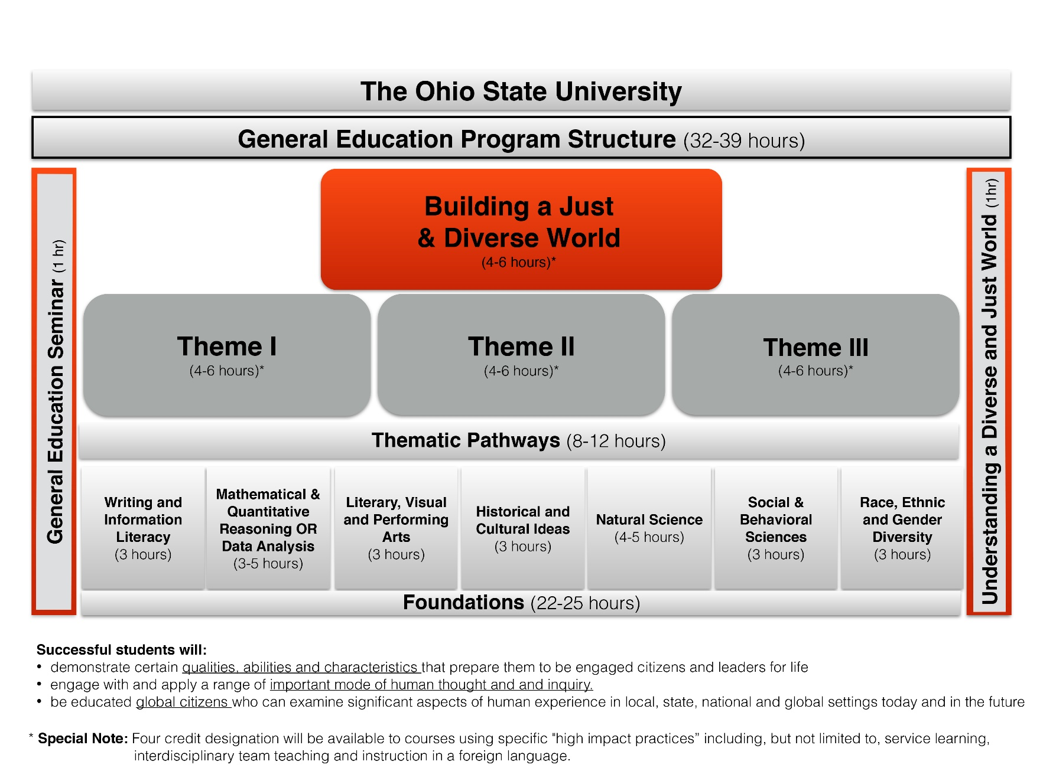
Appendix. Schematic of the proposed program. Please refer to the text of this proposal and to the proposal submitted by the OAA GE Review Committee for context and details.

